|  |
| --- |
| **LockedMe.com**  **(Application Screenshots)** |

**Version History:**

|  |  |
| --- | --- |
| **Author** | **Kumar Abhishek** |
| **Purpose** | **Screenshots of Application** |
| **Date** | **12th Aug 2021** |
| **Version** | **1.0** |

|  |  |
| --- | --- |
| **Application Name:** | **LockedMe.com** |
| **Developer:** | **Kumar Abhishek** |
| **Document Purpose:** | **Screenshots of Application** |

Contents

1. Main Menu Screen Shot 3

2. Display all files present in a directory 4

3. Add file in the existing directory 5

4. Delete a user specified file from the existing directory list 6

5. Search a user specified file from the main directory 7

6. Option to close the application 8

Checking for Invalid Choice 8

# Main Menu Screen Shot

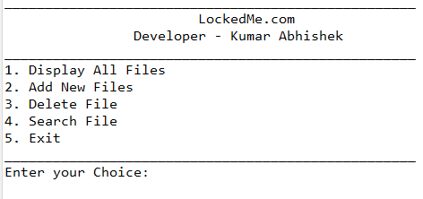

# Display all files present in a directory

# 

# Add file in the existing directory

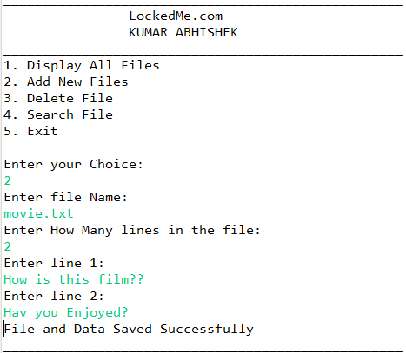

# Delete a user specified file from the existing directory list

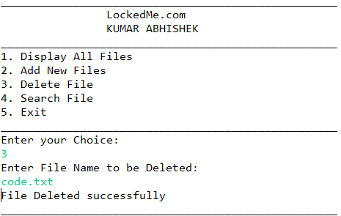

**Checking to delete a file “code.txt” which is not present in directory**

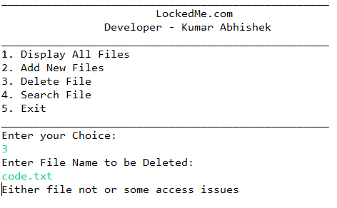

# Search a user specified file from the main directory

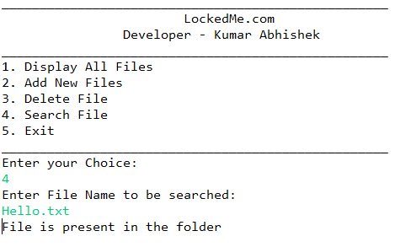

**Search for a file which is not present in a directory**

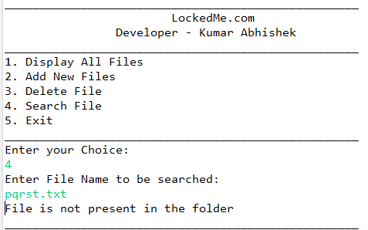

# Option to close the application

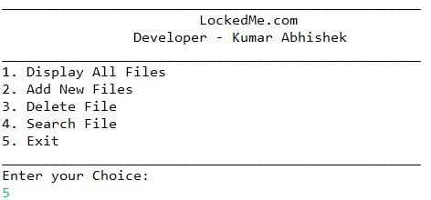

# Checking for Invalid Choice

